HILLY FIELDS FOOTBALL CLUB
SEASON 5: 1971-72
FIRST TEAM:
DULWICH LEAGUE:
P W D L F A Pts Pos
Division 2 17 5 1 1 31 58 11 7th
Junior Cup 6 3 2 1 23 14
Senior Cup 3 2 0 1 11 8
Friendly 2 1 1 0 10 3
TOTAL 28 11 4 13 75 83

Apps Gls Apps Gls
John Augustine 1 0 Bobby Head 12 13
Ron Bane 9 5 Bill Irwin 21 3
Terry Bellinger 1 0 Jack Jones 3 0
Bill Burke 11 5 Ray Laroche 6 1
Steve Chitty 19 9 Frank Marsh 14 2
Robin Cockle 1 1 George McDonald 1 0
John Costin 18 0 Tim Morton 2 0
Martin Formosa 23 0 Ray Norton 17 2
Keith Foster 12 0 Ian Parsons 21 3
Len Franklin 23 10 Don Redwood 1 0
Larry Garnham 19 5 Mick Roberts 4 0
Ray Griffin 23 1 Frank Ryan 24 10
Derrick Groom 6 1 John Shafto 2 0
John Harding 5 0 OG 4
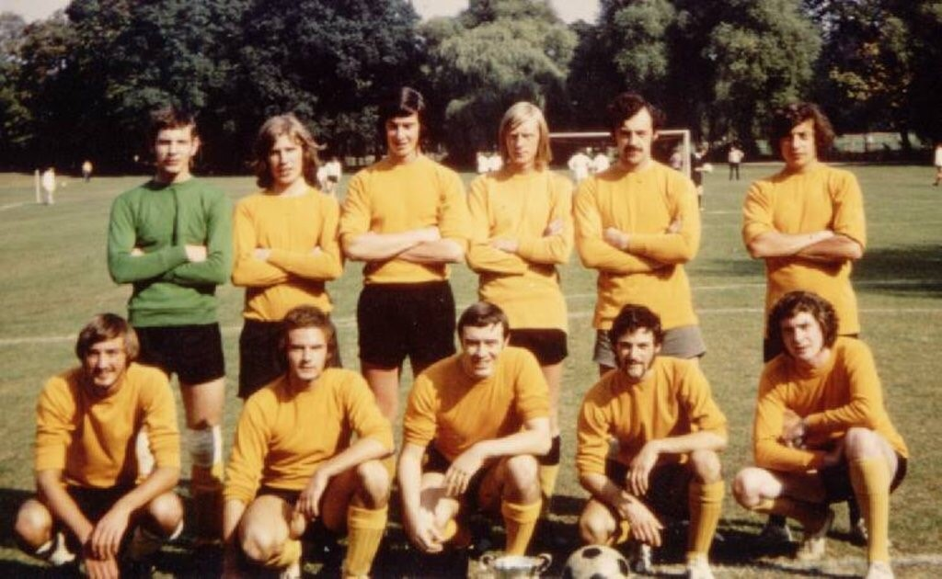
L-R Back: Keith Foster, John Costin, Frank Ryan, Larry Garnham, Ray Norton, Frank Marsh,
L-R Front: Tim Morton, Ian Parsons, Derrick Groom, Bill Irwin, Len Franklin

